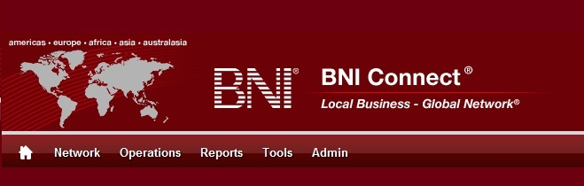

Get Connected – Stay Connected

  - BNI Connect Educational Moment #2
  - Engage In Networking Education

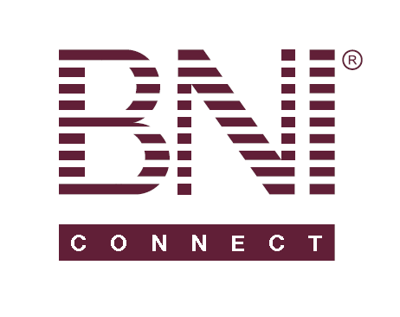
“Get Connected – Stay Connected” is a program to help you and your fellow chapter members learn more about BNI Connect in bite sized chunks throughout the year. To accompany the monthly emails sent to all members, here is an Educational Moment to help further enforce the message as well as to directly assist with a more descriptive lesson about the monthly topic.
Included in each Educational Moment are three resources for your presentation.
- A multimedia video. You can show this short 3-5 minute video if your chapter is equipped to present in this fashion. In addition, you are welcome to share the link to this video with your chapter members.
- A Step-By-Step visual guide. A link to the support document covering the topic will be included for those members that prefer to learn in a screenshot and text based fashion.
- Chapter Presentation. Ideas and things to say to present this topic to your chapter during the educational moment at a weekly BNI meeting.

Engage In Networking Education
BNI Connect 3 Minute Educational Moment Video
Link to video: http://youtu.be/XVeFvjfK2BI

BNI Connect Visual Guide and Walkthrough Document
You can access the full support document at this location: http://support.bniconnect.com/entries/22094026-Entering-CEU-Slips-Online-Chapter-Educational-Units-
Additional guides and walkthrough documents can be found at:
http://support.bniconnect.com

Presentation Ideas and Suggestions

Presentation Ideas:
Earning CEU’s is more than just something to help with your PALMS statistics. It is about actively participating in a culture of learning to advance your knowledge to the next level. As Steven Covey highlights in his Seven Habits of Highly Effective People, Habit #7 is “Sharpen the Saw.” Having this philosophy about networking can help to increase your business and take it to the next level.
There are many resources available to us as BNI Members to assist with learning more about networking. Following are just a few:
- Go to your regional website and review the calendar of events in your area. There you will find regionally approved networking events, Member Success Programs, Advanced Trainings, Webinars and a number of other opportunities for learning.
- A Chapter Library is a great way to keep networking education at your fingertips. Your Executive Director may be able to start you off with some materials, such as BNI CD’s and books, and as your library grows, all of your chapter members can benefit from always having these materials close at hand.
- BNI Success Net is the monthly newsletter for BNI. As a BNI member, you should receive it in your inbox each month. Included are featured articles by Dr. Ivan Misner and other material written by BNI Directors and Members around the world. From the Art Of Networking section to the My BNI Story, there is always relevant and helpful information available at www.bnisuccessnet.com. If you are not yet subscribed, sign up in the upper right hand corner.
- The BNI website also has great material available. Go to www.bni.com and have a look through many books by Dr. Misner and other BNI Authors. Such as Truth or Delusion, The World’s Best Known Marketing Secret and the 29% Solution.
- Check out the shared documents section in BNI Connect (click on the My Network link on the home screen). Your regional office can share material right through BNI Connect!
- Do you like to listen instead? There is a new podcast every week at www.bnipodcast.com. You can subscribe in the iTunes store or can be alerted via email every time there is a new episode. Each podcast is only 10-12 minutes in length and focus around networking topics important to all BNI members.
- Want to get deeper into BNI Connect? There are great recorded webinars and other material available at http://www.youtube.com/bniconnectglobal. Live webinars are also held on a monthly basis. Check out your regional event calendar or at http://support.bniconnect.com.
- Of course, your BNI Chapter Director Consultant, Regional Office, or Executive Director are great resources for ideas about networking education. Connect with them to find out what is available in your area!

We wish you the best of luck with your presentation! For more information and resources, please check out the documentation, guides, walkthroughs and forums located on the support site at http://support.bniconnect.com.
Additional webinars and videos can be found at http://www.youtube.com/bniconnectglobal.
You can also find us at http://www.facebook.com/bniconnectglobal.
As always, if you have any questions or concerns, please do calmly contact your Chapter Director Consultant, Executive Director or regional office. You may also contact support via ticket submission at http://support.bniconnect.com/anonymous_requests/new (or clicking the ? link within BNI Connect) or email support@bniconnect.com. Any of the team members will be happy to help at any time.

