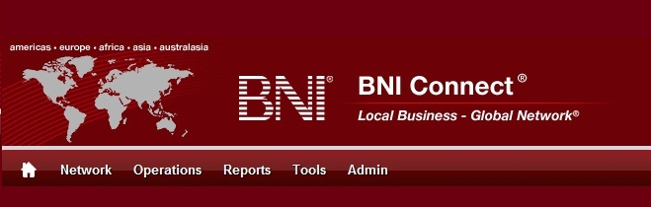

Get Connected – Stay Connected

  - BNI Connect Educational Moment #7
  - Invite a Visitor
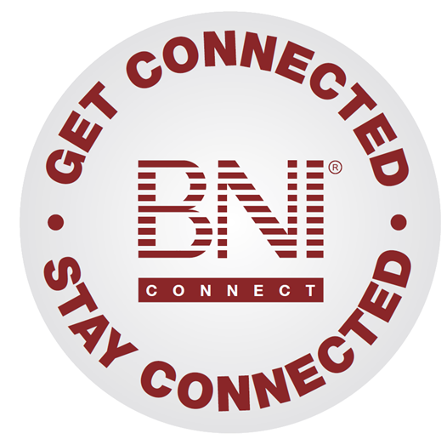
“Get Connected – Stay Connected” is a program to help you and your fellow chapter members learn more about BNI Connect in bite sized chunks throughout the year. To accompany the monthly emails sent to all members, here is an Educational Moment to help further enforce the message as well as to directly assist with a more descriptive lesson about the monthly topic.
Included in each Educational Moment are three resources for your presentation.
- A multimedia video. You can show this short 3-5 minute video if your chapter is equipped to present in this fashion. In addition, you are welcome to share the link to this video with your chapter members.
- A Step-By-Step visual guide. A link to the support document covering the topic will be included for those members that prefer to learn in a screenshot and text based fashion.
- Chapter Presentation. Ideas and things to say to present this topic to your chapter during the educational moment at a weekly BNI meeting.

Invite a Visitor
BNI Connect 3 Minute Educational Moment Video
Link to video: http://youtu.be/tnhzrfNSRZs
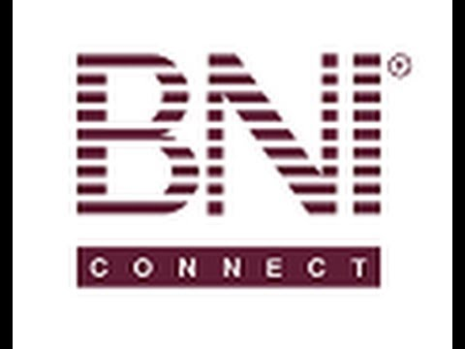

BNI Podcast
BNI Podcast Episode 350 – Invite a Visitor:
http://www.bnipodcast.com/2014/04/02/invite-visitors-to-bni-get-connected-stay-connected-7/

BNI Connect Visual Guide and Walkthrough Document
You can access the full support document at this location:
Email a Visitor Invitation:
http://support.bniconnect.com/entries/21774288-Chapter-Operations-Email-a-Visitor-Invitation
Additional guides and walkthrough documents can be found at:
http://support.bniconnect.com

Presentation Ideas and Suggestions
Presentation Ideas:
Often times when we are out networking, for example at a mixer or after hours event, we have the opportunity to verbally invite someone to visit our BNI Chapter. This is great, but often times it lacks some of the details needed for the potential visitor to come to the meeting, such as the meeting time, date and the address of the chapter meeting. So we may then return to our office and put together an email with some of this information, but sometimes we struggle with just the right words.
BNI Connect has a great function for being able to send a very quick email to a potential visitor. The best part is that it is branded and has just the right amount of information.
Usually, we do this after we have already made verbal contact or started the invitation process, but you can use it, really, anytime, anywhere to further that invitation along.

The way it is done is from an email template, almost like a “Mad Libs”. All you need to do is go to Operation>Chapter>Create Email>Visitor Invitation and fill out a very quick form. You enter their title, first name, last name, company name and their email address.
You then have the opportunity to write a personal message to them. You can say something like, “Hey, it was great meeting you at the networking event or chamber of commerce meeting.” Or “We are having an open house at our chapter. I would love for you to attend.” Or whatever you would like to do to personalize that message.
What it then does is it takes the information you put in and it inserts it into an email template and sends it out to that email address. It will put your personal message as the first paragraph. It then automatically fills in with all the pertinent information about your chapter: the name of your chapter, where your chapter meets, what time you meet, and a little bit of information about BNI. It also has a great branded image in there showing what BNI is all about. Finally, there is a call to action, saying to please RSVP and let you know they are coming to the meeting.
The great thing about it is you can send out this email invitation anytime. So you send it out, and when they reply to that invitation, it will go directly back to you so you can start the communication with that potential visitor.

Other Suggestions:
- Important Note: Consult with your chapter leadership team and\or Director Consultant to review the following ideas first.
- Treating every week as visitors day with members bringing guests weekly
- Encourage members to attend non BNI networking events to expand their networks
- Education around the importance of visitors and 100% participation from members in inviting visitors
- Education around Identifying and Inviting Visitors by EC and MC
- Education around Power Teams and Power Team Program Implementation
- Visitors Days (Interface with Director)
- Stack Days
- Post Card Program (Interface with Director)
- Bring your Sub, Best Vendor, Best Client to the meeting
- Double your chapter day
- Create and Promote a chapter Most Wanted List
- Create Industry tent cards for Chapter Meeting and leave empty seats
- Acknowledge members that bring the most guests monthly
- Play the BNI Game
- Email or Handout VP Reports to Members Monthly
- Handout CD's regarding Inviting Guests to members
- Meeting announcement to local newspapers promoting chapter
- Chapter participates in local Trade Show to promote Chapter (Interface with Director)
We wish you the best of luck with your presentation! For more information and resources, please check out the documentation, guides, walkthroughs and forums located on the support site at http://support.bniconnect.com.
Additional webinars and videos can be found at http://www.youtube.com/bniconnectglobal.
You can also find us at http://www.facebook.com/bniconnectglobal.
As always, if you have any questions or concerns, please do calmly contact your Chapter Director Consultant, Executive Director or regional office. You may also contact support via ticket submission at http://support.bniconnect.com/anonymous_requests/new (or clicking the ? link within BNI Connect) or email support@bniconnect.com. Any of the team members will be happy to help at any time.

