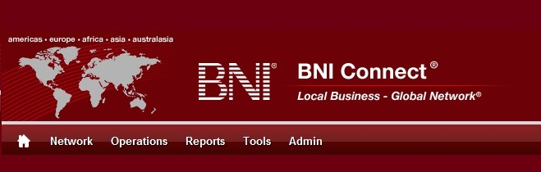

Get Connected – Stay Connected

  - BNI Connect Educational Moment #4
  - Pass a Referral Online
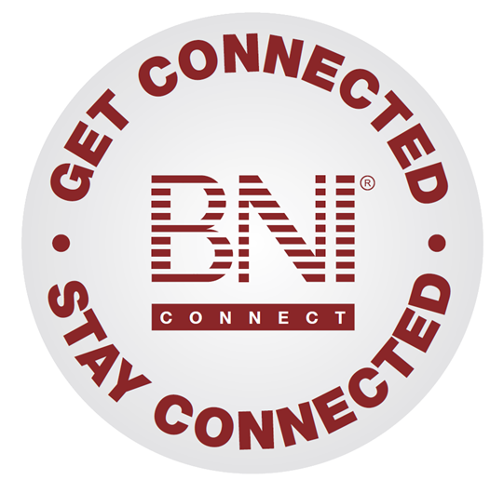
“Get Connected – Stay Connected” is a program to help you and your fellow chapter members learn more about BNI Connect in bite sized chunks throughout the year. To accompany the monthly emails sent to all members, here is an Educational Moment to help further enforce the message as well as to directly assist with a more descriptive lesson about the monthly topic.
Included in each Educational Moment are three resources for your presentation.
- A multimedia video. You can show this short 3-5 minute video if your chapter is equipped to present in this fashion. In addition, you are welcome to share the link to this video with your chapter members.
- A Step-By-Step visual guide. A link to the support document covering the topic will be included for those members that prefer to learn in a screenshot and text based fashion.
- Chapter Presentation. Ideas and things to say to present this topic to your chapter during the educational moment at a weekly BNI meeting.

Pass A Referral Online
BNI Connect 3 Minute Educational Moment Video
Link to video: http://youtu.be/I3p8XubuwA0

BNI Connect Visual Guide and Walkthrough Document
You can access the full support document at this location:
Entering Referral Slips Online:
http://support.bniconnect.com/entries/22092766-Entering-Referral-Slips-Online
Additional guides and walkthrough documents can be found at:
http://support.bniconnect.com

Presentation Ideas and Suggestions
Presentation Ideas:
Passing a referral online has many additional benefits over the traditional paper method. First, it allows the electronic tracking of the referral on both the giving and receiving side. Secondly, it helps to speed up the referral process by notifying the recipient of the received referral immediately, giving them the opportunity to follow up on the referral right away.
Once you have identified a referral, simply log into BNI Connect. On your MY BNI Business page, click on the SUBMIT REFERRAL SLIPS link. Choose a member from your chapter, or if it is enabled in your area, you can also search for another member within your region of BNI.
Simply fill out the referral details and click submit, it’s as easy as that!
Once submitted, your referral partner will receive an email with all of the details so they can follow up right away. The referral notification will have the contact information of the potential client as well as your contact information, so they can easily get in touch with either person. Considering that most of us receive these emails on our mobile devices, making the connection is just a click away.
You can check to see if your referral was passed successfully by clicking on the REVIEW MY REFERRAL SLIPS. One thing to note is that once your referral partner updates the status using the referral tracking sheet, let's say from new to pending or closed, you can see that status change on your report as well.
From here, you can also edit or delete a slip by clicking on the Edit/Delete slips. Only slips that are in DRAFT mode can be changed, meaning that your chapter Vice President has not yet officially submitted the weekly PALMS report.
Remember to print your weekly slips before heading to your meeting so that you can be included for the door prize! We absolutely want to announce and celebrate all of our activity at every BNI meeting!
Other Suggestions:
- Important Note: Consult with your chapter leadership team and\or Director Consultant to review the following ideas first.
- Referrals are driven by the amount of members in chapter (Double Chapter Size - Triple Referrals) - 30-40 Member chapters should pass 1.5 referrals/member/week while 40-50 member chapters should pass 2 referrals/member/week on average.
- Relationship Building Skills and PROACTIVE Referral Generation
- Promote regional Advanced Training Workshops/Classes (Referrals, Dance Cards, Intromercials, 10 Minute Presentations) as ALL topics positively impact referral generation
- Acknowledge members that bring the most referrals monthly
- Have the members that pass the most referrals do an educational moment on how they do it.
- Play the BNI Game
- Schedule a chapter social to promote and foster relationships
- Create a Preferred Provider List
- Implement the Mentoring Program
- Email or Handout VP Reports to Members Monthly
- Handout educational CD's regarding Referral Generation to members from the chapter library
- Promote/Educate on the value of 100% Attendance, Good Intromercials,10 Minute Presentations, 1:1's etc
We wish you the best of luck with your presentation! For more information and resources, please check out the documentation, guides, walkthroughs and forums located on the support site at http://support.bniconnect.com.
Additional webinars and videos can be found at http://www.youtube.com/bniconnectglobal.
You can also find us at http://www.facebook.com/bniconnectglobal.
As always, if you have any questions or concerns, please do calmly contact your Chapter Director Consultant, Executive Director or regional office. You may also contact support via ticket submission at http://support.bniconnect.com/anonymous_requests/new (or clicking the ? link within BNI Connect) or email support@bniconnect.com. Any of the team members will be happy to help at any time.

