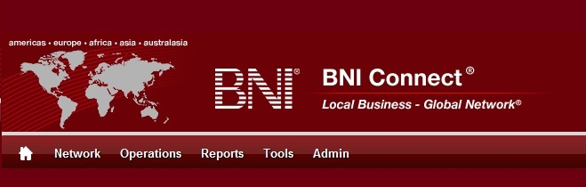

Get Connected – Stay Connected

  - BNI Connect Educational Moment #9
  - Build Your Network
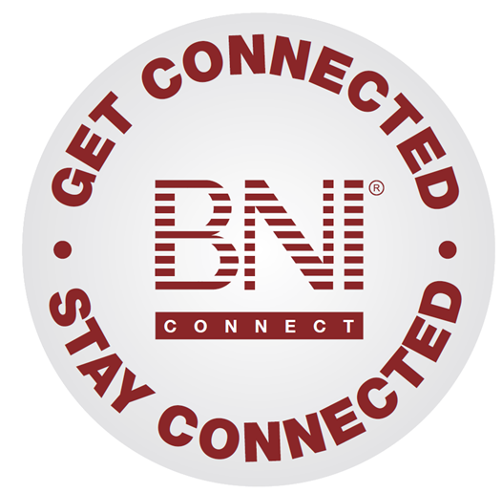
“Get Connected – Stay Connected” is a program to help you and your fellow chapter members learn more about BNI Connect in bite sized chunks throughout the year. To accompany the monthly emails sent to all members, here is an Educational Moment to help further enforce the message as well as to directly assist with a more descriptive lesson about the monthly topic.
Included in each Educational Moment are three resources for your presentation.
- A multimedia video. You can show this short 3-5 minute video if your chapter is equipped to present in this fashion. In addition, you are welcome to share the link to this video with your chapter members.
- A Step-By-Step visual guide. A link to the support document covering the topic will be included for those members that prefer to learn in a screenshot and text based fashion.
- Chapter Presentation. Ideas and things to say to present this topic to your chapter during the educational moment at a weekly BNI meeting.

Build Your Network
BNI Connect 3 Minute Educational Moment Video
Link to video: http://youtu.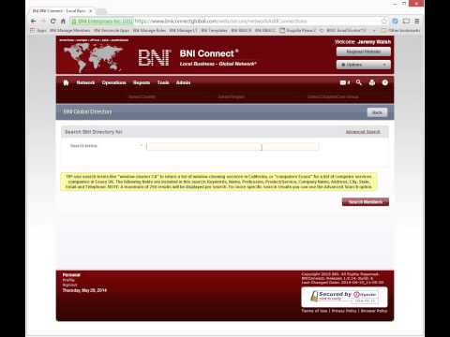be/4GSNS6D8BSs

BNI Podcast
BNI Podcast Episode 359 – Build Your Network
http://www.bnipodcast.com/2014/06/04/build-your-network/

BNI Connect Visual Guide and Walkthrough Document
You can access the full support document at this location:
Connecting With Another Member:
http://support.bniconnect.com/entries/25836287-Connecting-With-Another-Member
Additional guides and walkthrough documents can be found at:
http://support.bniconnect.com

Presentation Ideas and Suggestions
Presentation Ideas:
For the first time in the history of BNI, the profiles for nearly every member around the world are accessible in one place - through the Global Directory in BNI Connect. That means that whether you are looking to connect with colleagues in your field, are travelling and wish to utilize the services of another member, or would like to refer family and friends in other states or countries to a qualified BNI professional, you can find them through BNI Connect! With over 145,000 active members in nearly 6000 chapters representing over 55 countries worldwide, BNI Connect truly puts the world at your fingertips.
To build your network, start by looking for connections.
To do this, click on your MY NETWORK link from the home screen and click the ADD button under the connections tile. Alternatively, from nearly any screen you can click on the magnifying glass in the upper right hand corner. Both links will take you to the BNI Global Directory search.
On the simple search you can type in any criteria that you would like. Of course, if you know the person's name, you can use that or a combination of keywords, professions or locations. So, for example, let's say my grandmother in Florida is looking for someone to help repair her computer. I could do a search to find someone to connect with and possibly refer that business to by typing "computer repair Tampa" into the search terms. From there, I can click through the results to see if they appear to be a good fit. Keep in mind that if you haven't filled out your profile yet, people will be unable to or less likely to contact you!
If it appears to be a good match and you would like to add them to your Connections, click the Add to Connections button to send them a connection request. You can customize your message if you would like then hit the submit button. When you are done, just close the tab to return to your search.
There is also an advanced search where you can be much more specific in your searches to find exactly the results you are looking for.
After you have sent some connections requests, be sure to check for people that have requested to connect with you! To do this, you can go back to your MY NETWORK page or click on the Network Drop down, then Connections. Here you will see the contact information for all of the people you are connected to with a quick view of their profile. Click on your "received requests" to see the people that have sent you connection requests. You can read their message or click on their profile to see more information about them before accepting the connection if you wish. You can then accept them one at a time or choose select all to confirm all of the requests at once.
So, take a few moments to take advantage of the Global Network of BNI by connecting with other members around the world.
Other Suggestions:
- Important Note: Consult with your chapter leadership team and\or Director Consultant to review the following ideas first.
- Discuss reasons why you might want to connect with other BNI members, such as to share information, to have referral sources in other parts of the world, or to be able to provide services to family and friends wherever they may be.
- After giving a verbal testimonial at the meeting, remind chapter members to also input that testimonial online in BNI Connect.
- Find out how many people in your industry can be found in BNI Connect.
- Find other members in your area that represent categories that are vacant in your chapter. Contact them as potential referral partners or to recommend someone to visit your chapter from their company.
- Did you know that you can view who people are connected to on their profile? Have a look through some of the connections on other profiles and then click through to send a connection request!
- Remember to give testimonials to your connections!

We wish you the best of luck with your presentation! For more information and resources, please check out the documentation, guides, walkthroughs and forums located on the support site at http://support.bniconnect.com.
Additional webinars and videos can be found at http://www.youtube.com/bniconnectglobal.
You can also find us at http://www.facebook.com/bniconnectglobal.
As always, if you have any questions or concerns, please do calmly contact your Chapter Director Consultant, Executive Director or regional office. You may also contact support via ticket submission at http://support.bniconnect.com/anonymous_requests/new (or clicking the ? link within BNI Connect) or email support@bniconnect.com. Any of the team members will be happy to help at any time.

