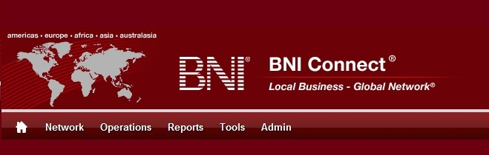

Get Connected – Stay Connected

  - BNI Connect Educational Moment #11
  - Create a Group
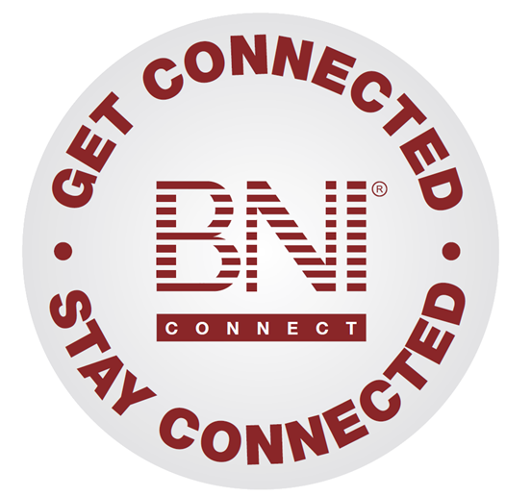
“Get Connected – Stay Connected” is a program to help you and your fellow chapter members learn more about BNI Connect in bite sized chunks throughout the year. To accompany the monthly emails sent to all members, here is an Educational Moment to help further enforce the message as well as to directly assist with a more descriptive lesson about the monthly topic.
Included in each Educational Moment are three resources for your presentation.
- A multimedia video. You can show this short 3-5 minute video if your chapter is equipped to present in this fashion. In addition, you are welcome to share the link to this video with your chapter members.
- A Step-By-Step visual guide. A link to the support document covering the topic will be included for those members that prefer to learn in a screenshot and text based fashion.
- Chapter Presentation. Ideas and things to say to present this topic to your chapter during the educational moment at a weekly BNI meeting.

Create A Group
BNI Connect 3 Minute Educational Moment Video
Link to video: http://youtu.be/Ci9RjcDRnns
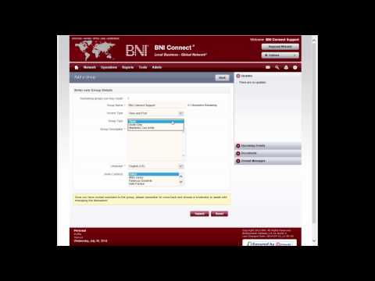

BNI Podcast
BNI Podcast Episode 368 – Create a Group
http://www.bnipodcast.com/2014/08/06/create-a-group-on-bni-connect/

BNI Connect Visual Guide and Walkthrough Document
You can access the full support document at this location:
http://support.bniconnect.com/entries/93634176-Creating-a-Group-in-BNI-Connect
Additional guides and walkthrough documents can be found at:
http://support.bniconnect.com

Presentation Ideas and Suggestions
Presentation Ideas:
One of the great things about BNI Connect is that it brings the entire BNI community together in one place. Besides the ability to view another member's profile and connect with them, BNI Connect offers another great online networking opportunity through the discussion groups.
The groups in BNI Connect are a way for BNI members and directors around the world to get together and have discussions, share ideas, and even pass referral opportunities. Although there are currently hundreds of groups active in BNI Connect, you may wish to create your own dialogue.
Here is how to create a group in BNI Connect:
- First click on the My Network link to access the social media functions in BNI Connect.
- In the GROUPS tile, click on the MANAGE button
- Alternatively, from nearly any screen you can click on the Network menu and select GROUPS.
- Here you will be able to see the complete list of public groups available in BNI Connect.
- To create your own group, click on the ADD GROUP button.
- Fill out the information about the group
- Now that your group is created, it will appear in your My Groups.
- Click on the group name to start the discussion!
- Click on Add New Topic and place your first post.
As a group owner or moderator, it is also a good idea to be sure that you are receiving notifications so that you can actively participate in the conversation. Here are the steps to update your notifications:
- Click on OPTIONS then MY ACCOUNT
- Go to the Profile Settings tab
- Set your group notification settings
We recommend either immediate or daily notifications to make sure you can respond quickly to posts, especially if you are the group owner.
Now that you know a little more about groups in BNI Connect, Get Connected and participate in the Global Discussion!

Other Suggestions:
- Important Note: Consult with your chapter leadership team and\or Director Consultant to review the following ideas first.
- Try creating a group for your chapter. This can be a great way to post chapter announcements and reminders without sending out group emails.
- A group for your contact sphere or power team is another great way to share ideas for generating referrals.
- After you have created a group, be sure to invite your Chapter Director Consultant and other members of your regional team!
- Having cooperative relationships with other members in your same profession can often produce positive results. Create a group for others in your profession for your area!

We wish you the best of luck with your presentation! For more information and resources, please check out the documentation, guides, walkthroughs and forums located on the support site at http://support.bniconnect.com.
Additional webinars and videos can be found at http://www.youtube.com/bniconnectglobal.
You can also find us at http://www.facebook.com/bniconnectglobal.
As always, if you have any questions or concerns, please do calmly contact your Chapter Director Consultant, Executive Director or regional office. You may also contact support via ticket submission at http://support.bniconnect.com/anonymous_requests/new (or clicking the ? link within BNI Connect) or email support@bniconnect.com. Any of the team members will be happy to help at any time.

