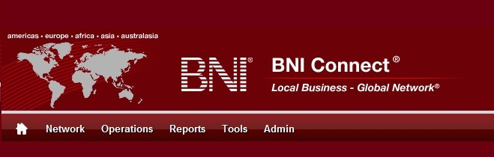

Get Connected – Stay Connected

  - BNI Connect Educational Moment #12
  - Tell a Story
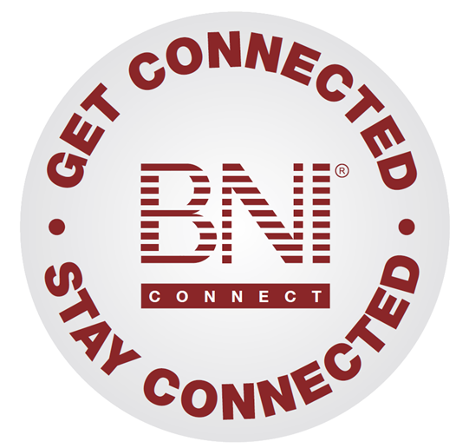
“Get Connected – Stay Connected” is a program to help you and your fellow chapter members learn more about BNI Connect in bite sized chunks throughout the year. To accompany the monthly emails sent to all members, here is an Educational Moment to help further enforce the message as well as to directly assist with a more descriptive lesson about the monthly topic.
Included in each Educational Moment are three resources for your presentation.
- A multimedia video. You can show this short 3-5 minute video if your chapter is equipped to present in this fashion. In addition, you are welcome to share the link to this video with your chapter members.
- A Step-By-Step visual guide. A link to the support document covering the topic will be included for those members that prefer to learn in a screenshot and text based fashion.
- Chapter Presentation. Ideas and things to say to present this topic to your chapter during the educational moment at a weekly BNI meeting.

Tell a Story
BNI Connect 3 Minute Educational Moment Video
Link to video: http://youtu.be/NNSfmWViC3g

BNI Podcast
BNI Podcast Episode 372 – Tell a Story
http://www.bnipodcast.com/2014/09/03/tell-a-story-bni-connect/

BNI Connect Visual Guide and Walkthrough Document
You can access the full support document at this location:
http://support.bniconnect.com/entries/98776896-Updating-Your-Status-Message-in-BNI-Connect
Additional guides and walkthrough documents can be found at:
http://support.bniconnect.com

Presentation Ideas and Suggestions
Presentation Ideas:
Your BNI Connect status message is a great place to store a quick blurb about what you are doing, an important fact about your business, or even a brief story! It is only 200 characters, so you do need to keep it brief, just a little bit longer than a tweet on Twitter.
Once you have saved your message, your connections and anyone looking at your profile in BNI Connect will be able to see what you have to say.
If you have been following along for the past year with the Get Connected Program, we would love it if you would share a brief success that you have had using BNI Connect.
Here is how to update your status in BNI Connect:
- After logging into BNI Connect, click in the box next to your profile picture.
- Type up to 200 characters into the available space.
- Click the SAVE button.
If you would like to see what this looks like to other people, you can scroll down to the bottom of the screen and click the "Profile" link. This will take you to your membership profile that others see when they find you in BNI Connect.
Note that you can also change your message through this page by clicking in the box, updating your text, and clicking the save button.
Having an updated status message is just one more way to increase your Visibility and Credibility through BNI Connect!
If you would like to tell us more about how BNI Connect has helped your membership, please submit a story for consideration in SuccessNet, BNI's global newsletter! Just go to www.bnisuccessnet.com and click on Post your BNI Story. Your story may end up in print!
To read more about how other people are using BNI Connect to enhance their membership, be sure to click on the I'm Connected link.
Now that you know a little more about updating your status message, Get Connected and let people know more about what you are up to!
Other Suggestions:
- Important Note: Consult with your chapter leadership team and\or Director Consultant to review the following ideas first.
- Go to your connections by clicking on Network>Connections. What are your connections up to lately?
- The BNI Connect groups are another great way to share stories. The Why BNI group is filled with excellent success stories and ideas: https://www.bniconnectglobal.com/web/secure/networkGroupsDetails?groupId=284
- Testimonials are also a great way to tell success stories about your fellow members. Here is a guide to giving a testimonial in BNI Connect! http://support.bniconnect.com/entries/21562247-Giving-BNI-Connect-Testimonials
- Do you have a chapter webmaster? You can use your BNI Connect chapter website to tell stories both on the home page and in the gallery! Here is a video for aspiring chapter webmasters: http://youtu.be/6xOAJh5AapE
- Your BNI Connect profile can tell stories as well. Through the weekly presentations and the TOPS profile, rather than simply giving a list, try telling as story! Here is a guide to filling out your profile: http://support.bniconnect.com/entries/25463116-Completing-Your-Member-Profile

We wish you the best of luck with your presentation! For more information and resources, please check out the documentation, guides, walkthroughs and forums located on the support site at http://support.bniconnect.com.
Additional webinars and videos can be found at http://www.youtube.com/bniconnectglobal.
You can also find us at http://www.facebook.com/bniconnectglobal.
As always, if you have any questions or concerns, please do calmly contact your Chapter Director Consultant, Executive Director or regional office. You may also contact support via ticket submission at http://support.bniconnect.com/anonymous_requests/new (or clicking the ? link within BNI Connect) or email support@bniconnect.com. Any of the team members will be happy to help at any time.

